Department of Computer Science
College of Information Technology and Computing
CS 412 – CS Elective 2 (Affect Computing)
Laboratory Manual Submission Form

Sem and SY: | 1st Sem, Sy 2026-2027
Topic: | Facial Emotion Recognition (FER2013) | Score:
Week No(s): | 7
Date: | October 19, 2026
Name: | Jhey Gulde | Course & Section: CS412 - CS4A

Answer Starts here:
Notebook and output files: https://github.com/Jhey20-sys/Facial-Emotion-Recognition (Week7_Facial_Emotion_Recognition.ipynb). Track used: Track B (CNN deep features, MobileNetV2). Models: Logistic Regression and SVM (RBF kernel). Roles: individual work. I did the data checking, face detection, feature extraction, model training, evaluation and this write-up.
SANITY CHECK: FER2013 FOLDERS AND LABELS
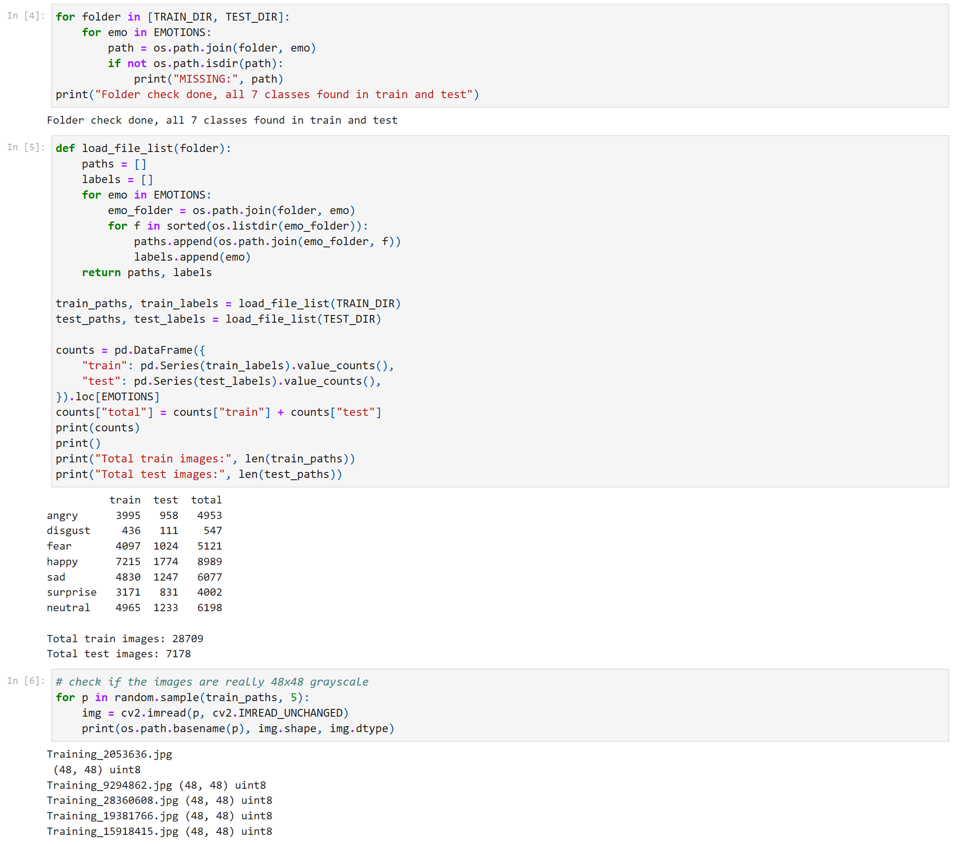
Folder check, image counts per class and image-size check
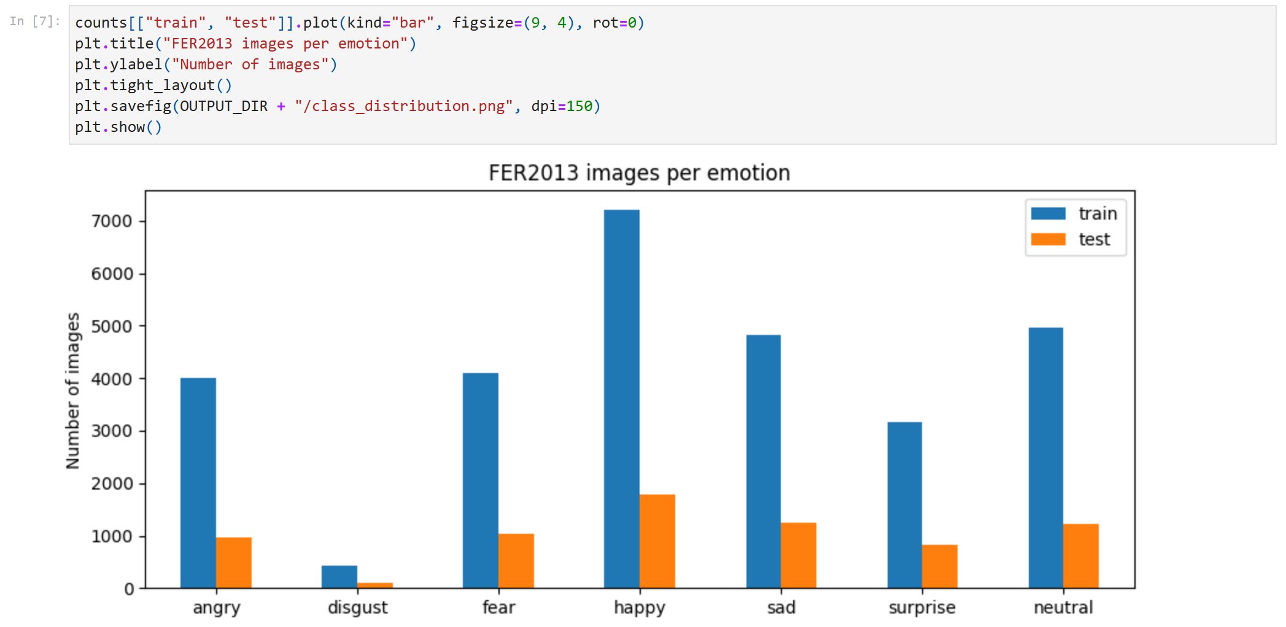
Class distribution of the train and test sets
DISCUSSION:
Before doing anything else, I checked that the seven emotion folders (angry, disgust, fear, happy, sad, surprise, neutral) exist in both data/train and data/test. Each image's label comes from its folder name, so this check makes sure every image gets the right label. The dataset has 28,709 training images and 7,178 test images, and the random samples I checked are all 48x48 grayscale (uint8), which matches the FER2013 spec. The classes are very imbalanced: happy has 7,215 training images but disgust has only 436. Because of this, I report macro-averaged metrics (every class counts equally) and use class_weight="balanced" in both models.
MILESTONE 1: FACE DETECTION & VISUAL CHECK
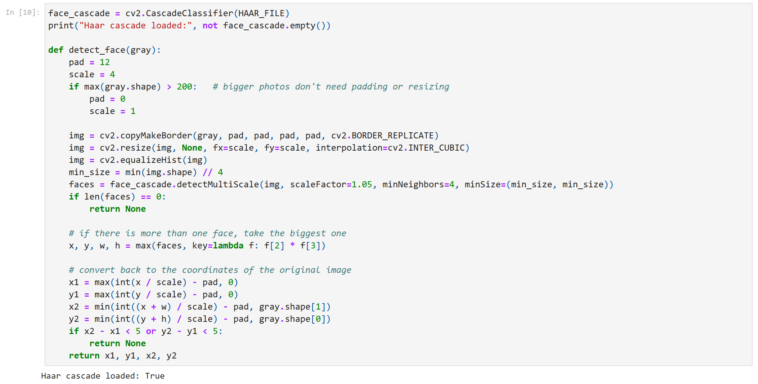
Haar cascade face detector (largest face is used)
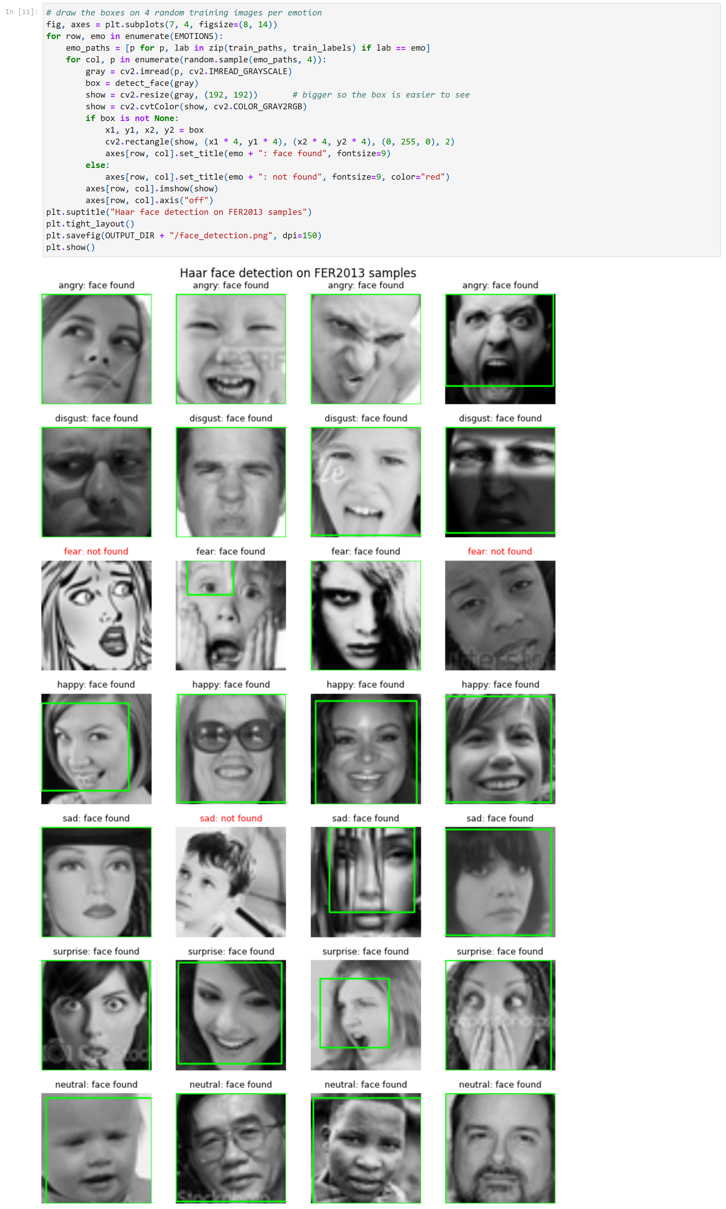
Face boxes drawn on 4 random training images per emotion
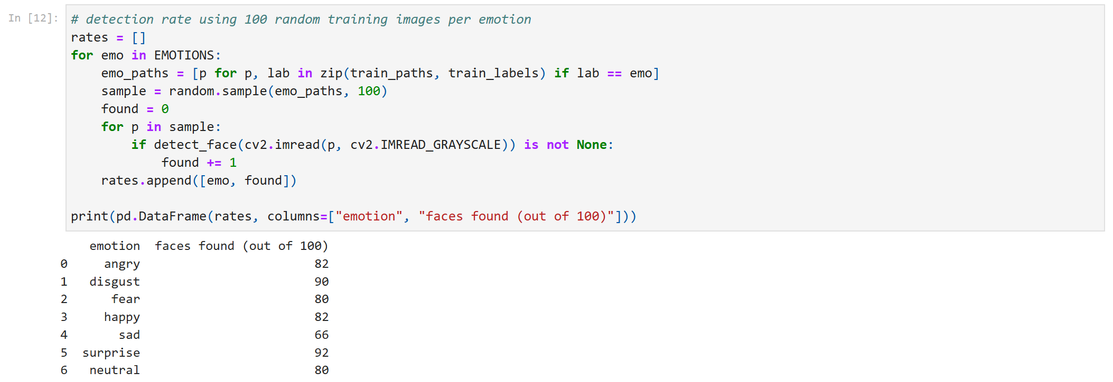
Detection rate on 100 random training images per emotion
DISCUSSION:
I used OpenCV's Haar cascade (haarcascade_frontalface_default.xml) as the face detector. FER2013 images are tiny and the face already fills almost the whole picture, so the cascade missed a lot of faces at first (about 66% detected in a quick test). Adding a 12-pixel border around the image and making it 4x bigger before detecting raised this to about 82%. When more than one face is found, I keep the biggest box. The green boxes in the figure show that the detector finds the face correctly for all seven classes. On the 100-image samples the detection rate was highest for surprise (92/100) and lowest for sad (66/100). On the full dataset, a face was found in 81.3% of training images and 81.3% of test images. Most misses are faces turned to the side, faces partly covered by a hand, or very dark images. When no face is found, the whole 48x48 image is used, which is safe because FER2013 images are already cropped faces.
MILESTONE 2: FEATURE EXTRACTION (TRACK B, CNN DEEP FEATURES)
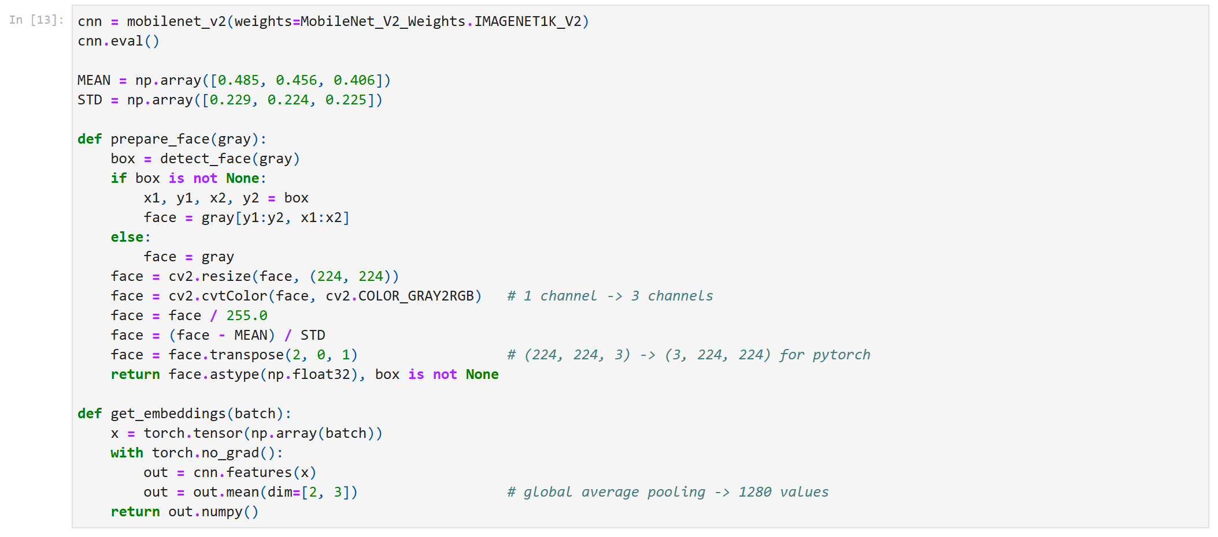
Face crop, resize to 224x224, grayscale to 3 channels, MobileNetV2 embedding
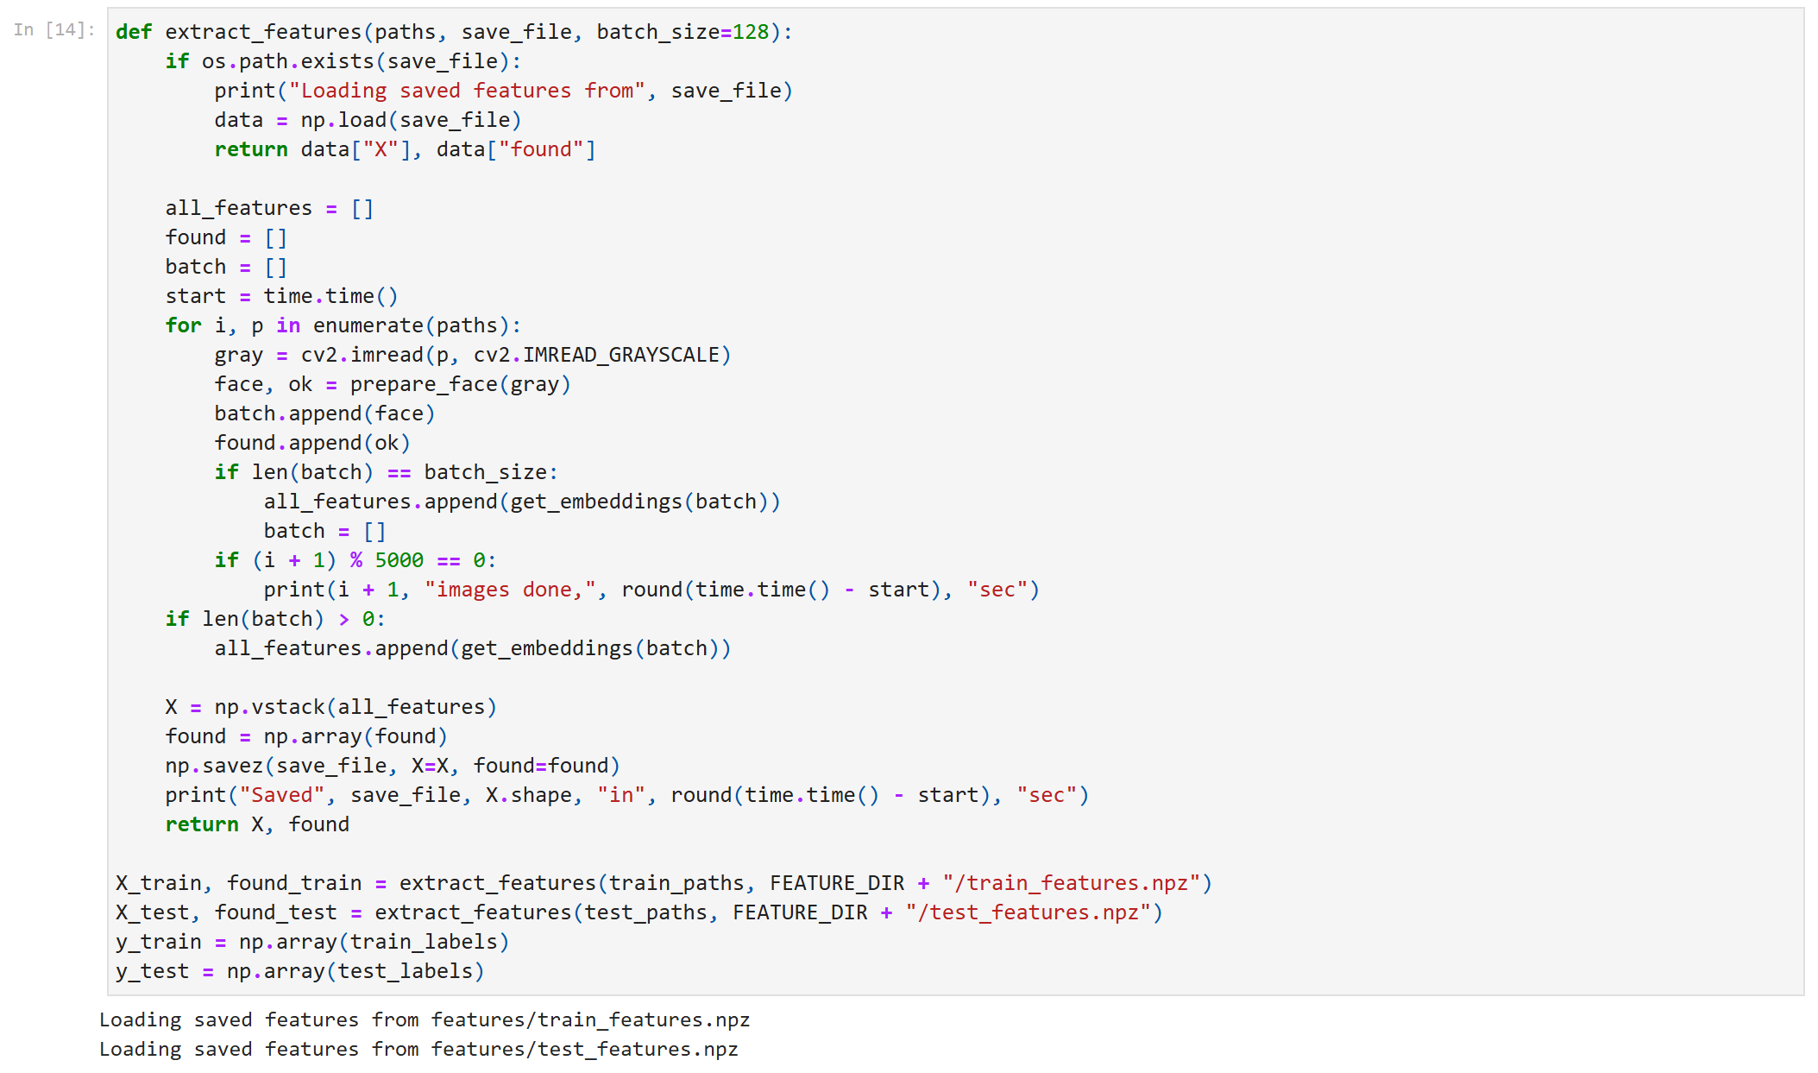
Feature extraction for train and test (this run loads the features saved by the first full run)
DISCUSSION:
For every image I crop the detected face, resize it to 224x224 (the input size MobileNetV2 was trained on), copy the gray channel into 3 channels because the CNN expects RGB, and normalize it with the ImageNet mean and standard deviation. The image then goes through a pretrained MobileNetV2 (ImageNet weights, no fine-tuning). Global average pooling on the last convolutional layer gives a fixed-length vector of 1,280 numbers per image. Extracting all 35,880 images takes about 20 minutes on my laptop's CPU, so the features are saved to the features folder and loaded on later runs. Train features come only from data/train and test features only from data/test.
TRAIN–TEST SPLIT OVERVIEW
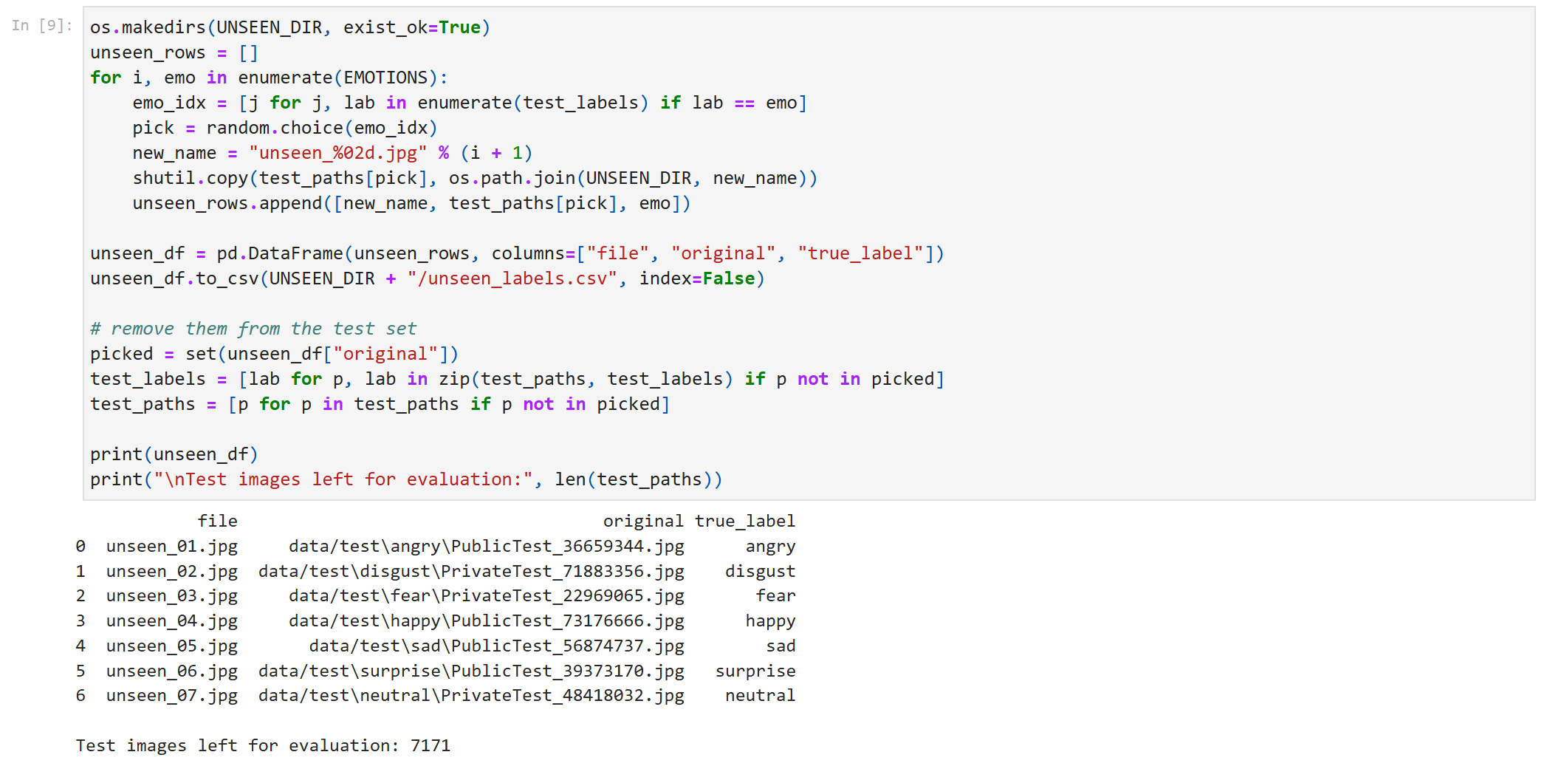
Seven test images set aside for the predict-function demo
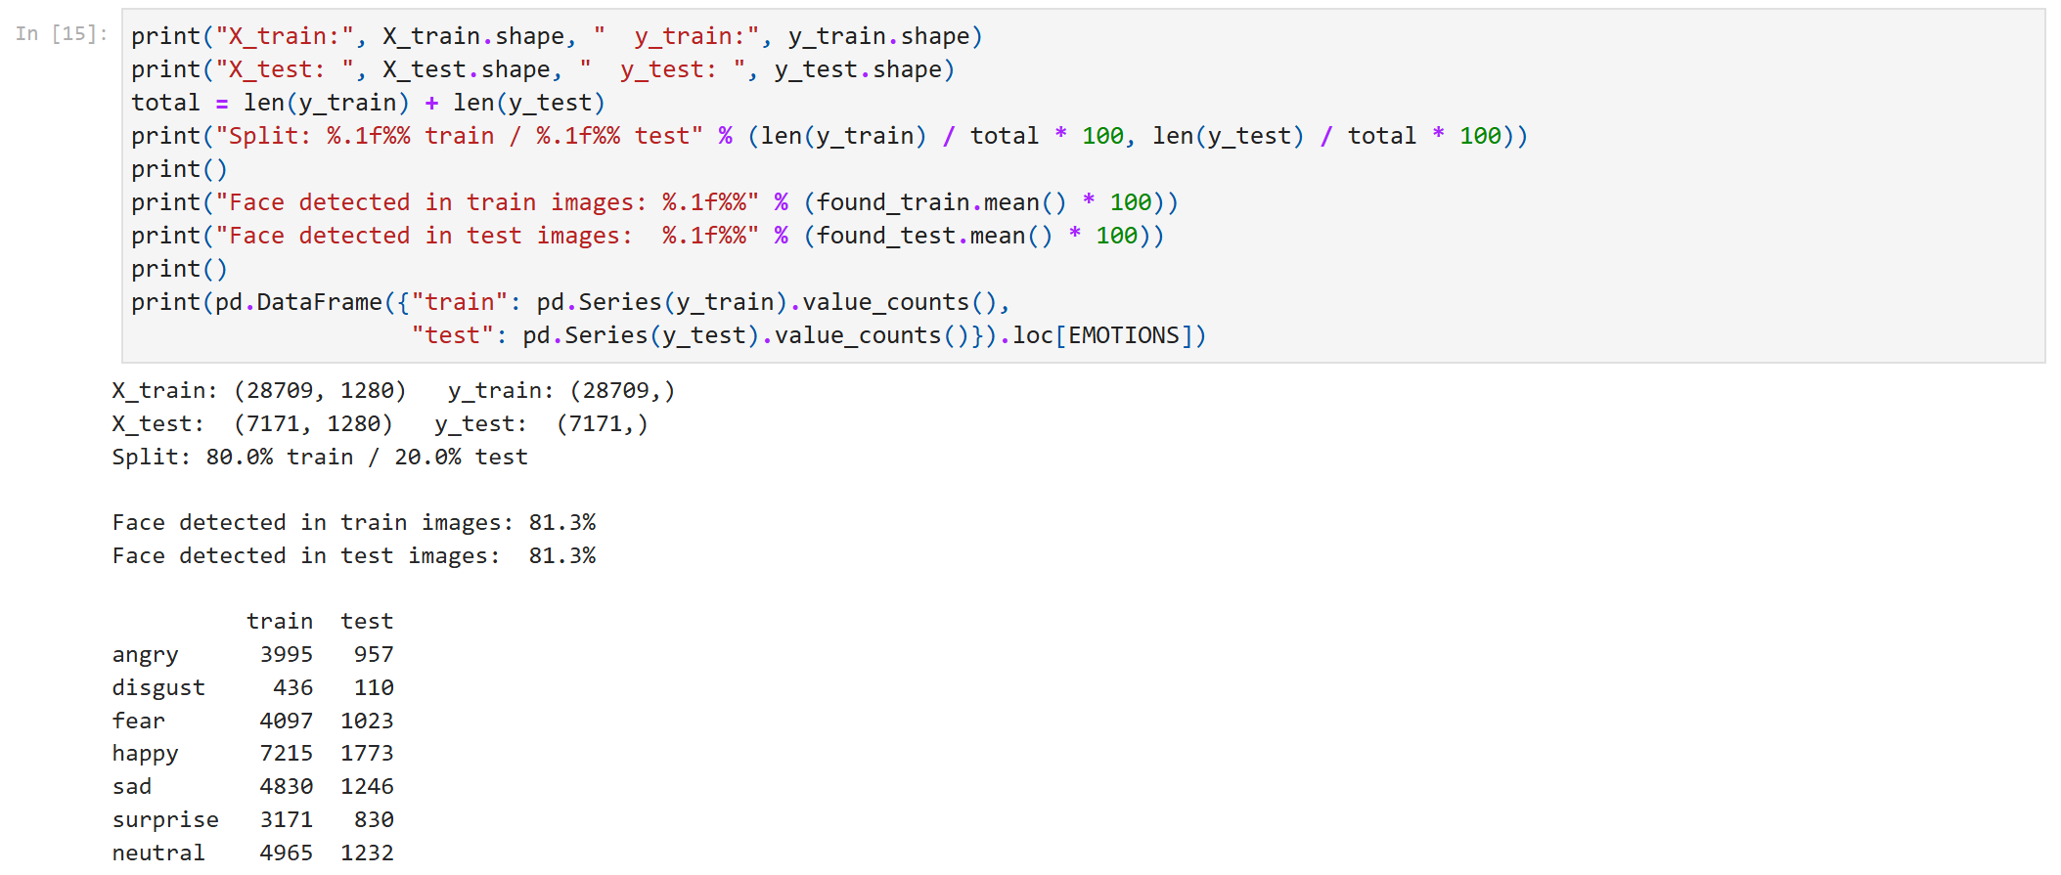
Split verification: feature shapes, split ratio, detection rate and class counts
DISCUSSION:
I used the official FER2013 split: data/train (the original Training set, 28,709 images) and data/test (PublicTest + PrivateTest). I took one test image per emotion out of the test set and put it in the unseen_images folder for the predict function demo, which leaves 7,171 test images for evaluation. That gives a split of about 80% train and 20% test. X_train is 28,709 x 1,280 and X_test is 7,171 x 1,280, and all seven classes appear in both sets with almost the same proportions. The test set is never used for training or tuning. To choose Logistic Regression's C, I used a separate 10% validation split taken from the training set.
MODEL TRAINING EVIDENCE
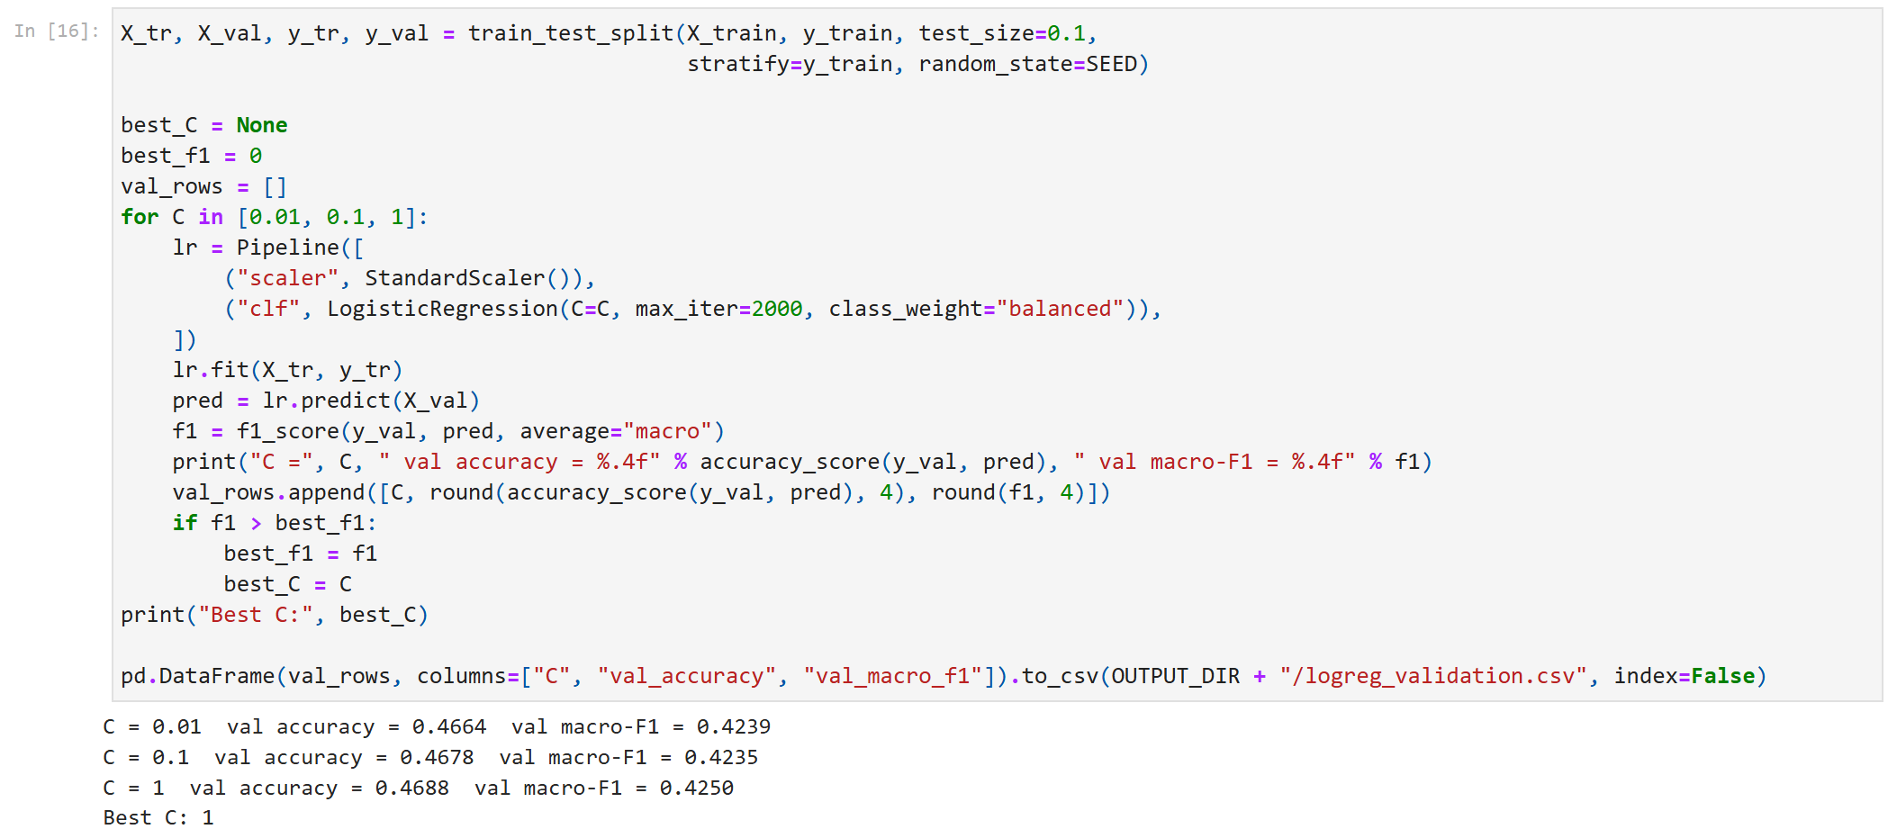
Choosing C for Logistic Regression on the validation split
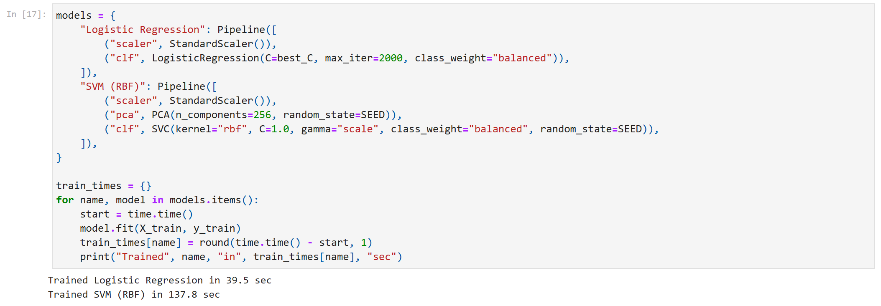
Training both models on the full training set
Model | Preprocessing | Key hyperparameters | Train time
Logistic Regression | StandardScaler on the 1,280 CNN features | C = 1 (picked on validation), L2 penalty, lbfgs, max_iter = 2000, class_weight = balanced | 40 s
SVM (RBF) | StandardScaler, then PCA to 256 components | kernel = rbf, C = 1.0, gamma = scale, class_weight = balanced | 138 s

DISCUSSION:
Both models are trained on the same MobileNetV2 features with random_state = 42, so the comparison is fair and the results are reproducible. For Logistic Regression I standardized the features and tried C = 0.01, 0.1 and 1 on the validation split. The three values gave almost the same macro-F1 (0.423 to 0.425), so the model is not very sensitive to C. C = 1 was slightly best, so I retrained with it on the full training set. For the second model I chose an SVM with an RBF kernel. An RBF SVM can draw curved boundaries between classes and is commonly used on top of CNN embeddings, while Random Forest splits on one feature at a time, which is not a good fit for 1,280 dense CNN features. I also trained a Random Forest to check this choice (see the Random Forest comparison section). The SVM needs scaled features, and PCA to 256 dimensions makes it train much faster. Both models use class_weight="balanced" so the small disgust class is not ignored.
EVALUATION EVIDENCE
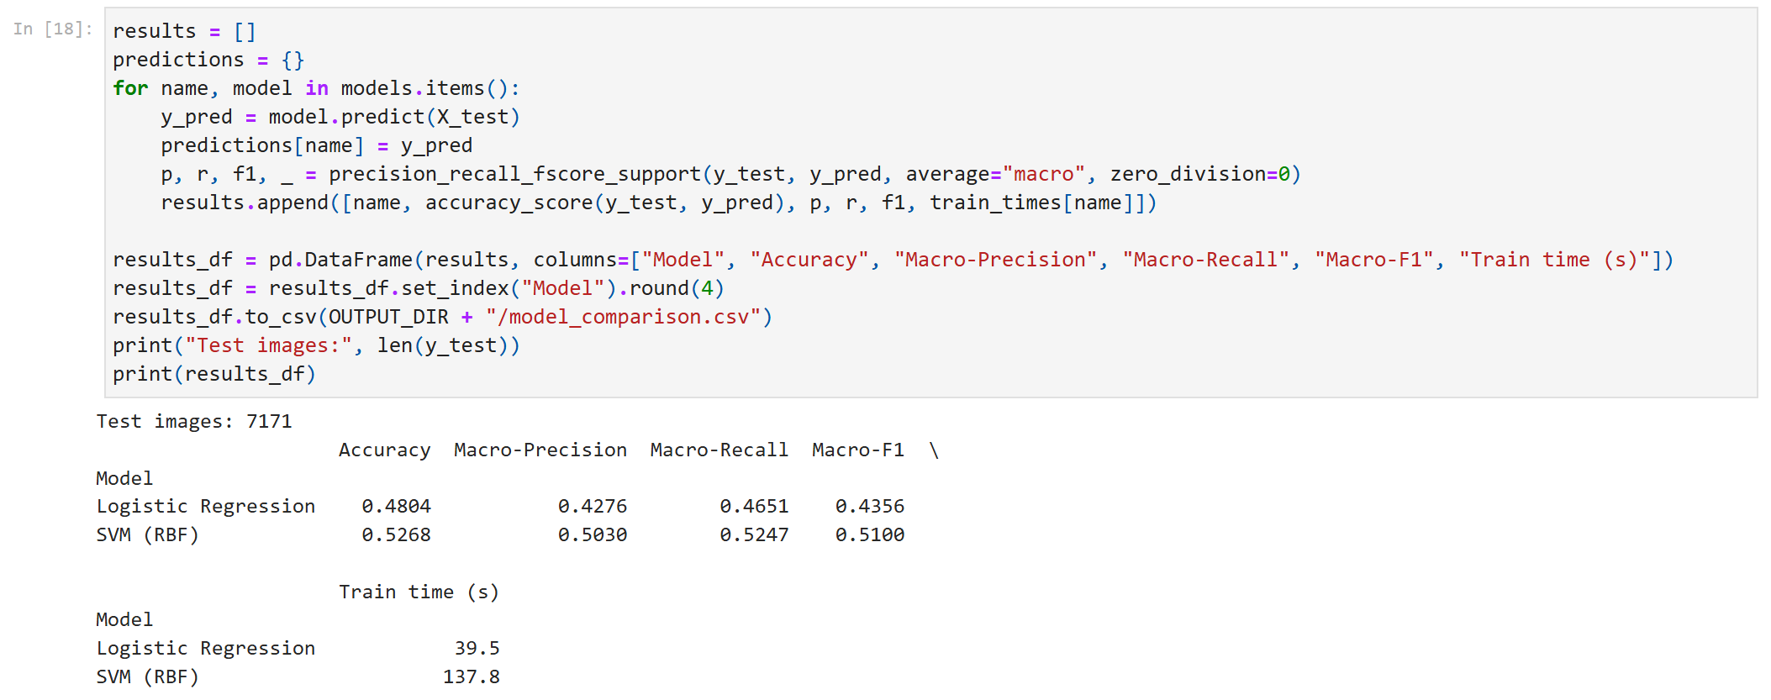
Overall accuracy and macro scores on the 7,171 test images
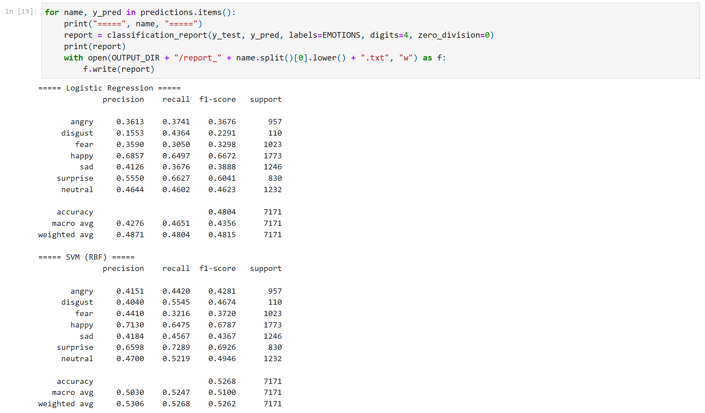
Classification reports (precision / recall / F1 per class)
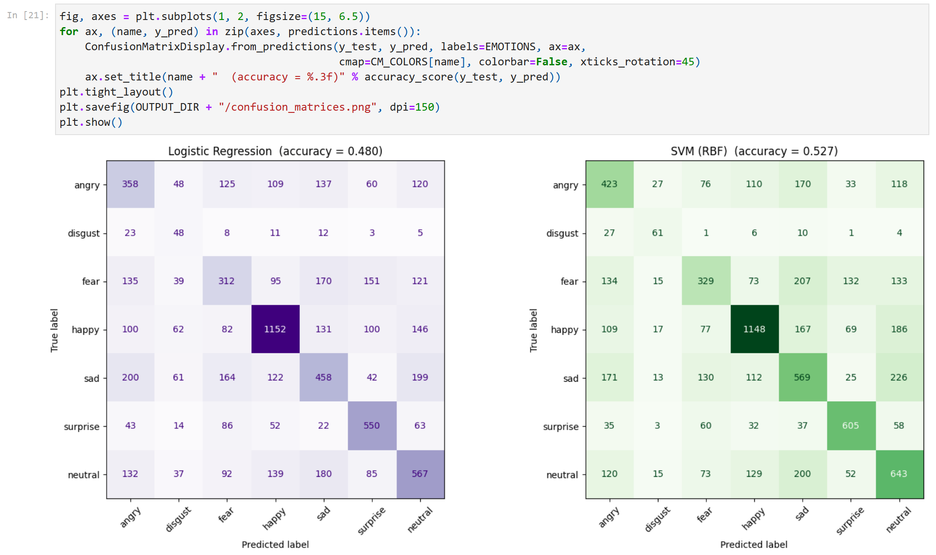
7x7 confusion matrices (counts): purple = Logistic Regression, green = SVM
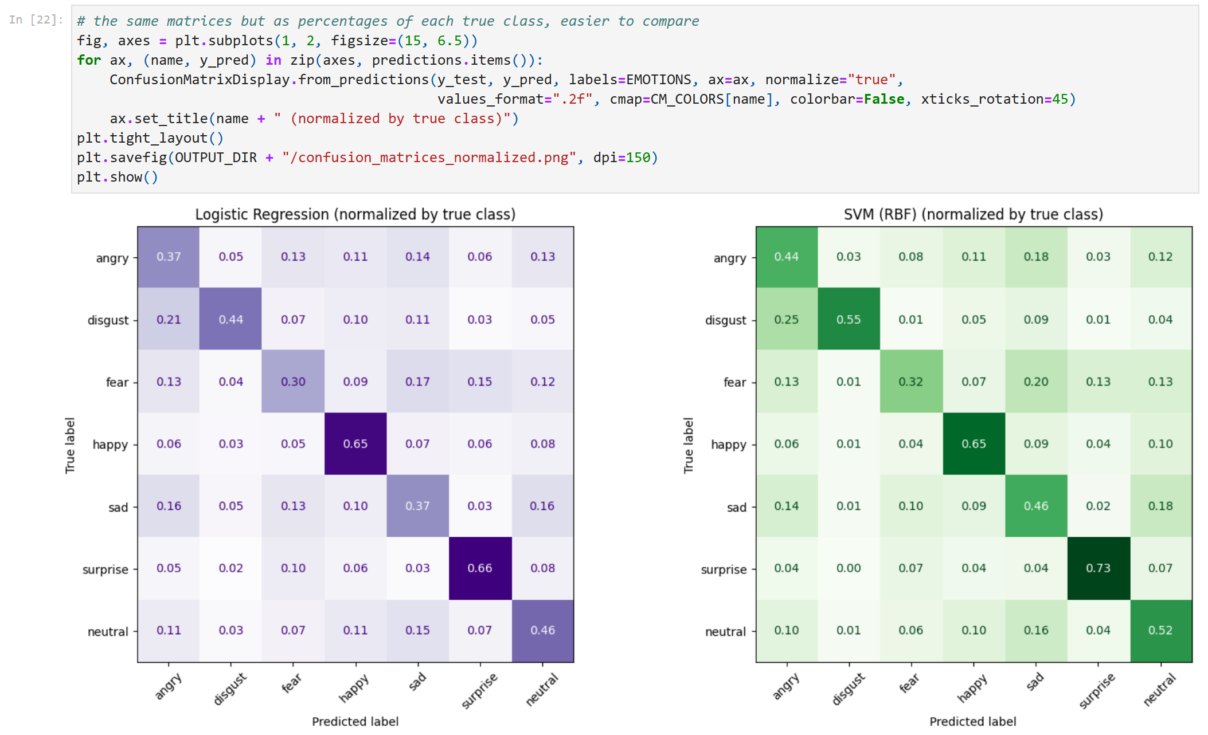
Confusion matrices normalized by the true class
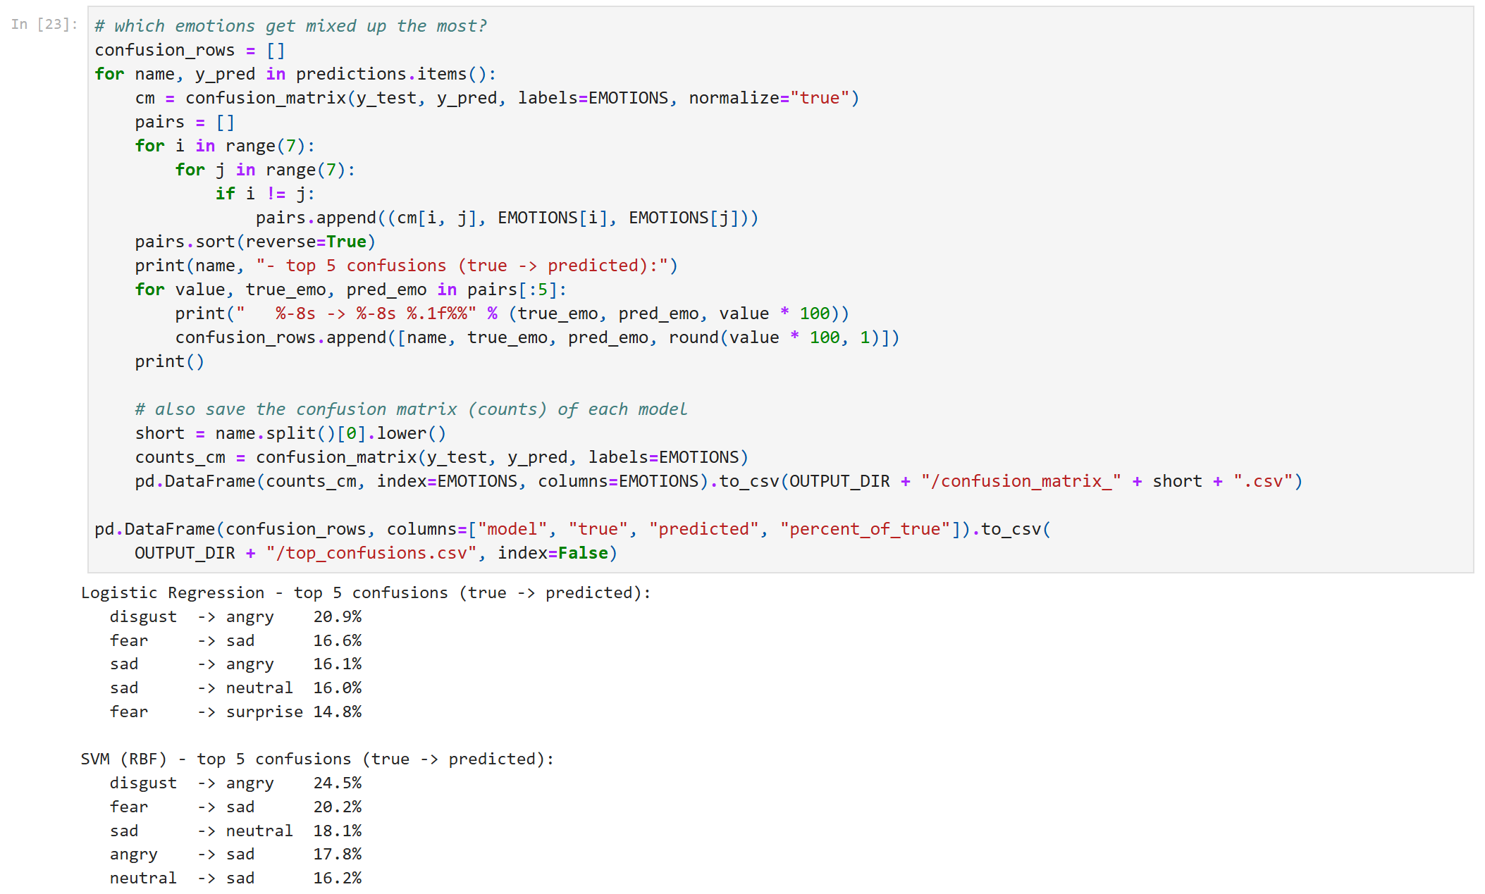
Most common confusions, also saved to CSV
DISCUSSION:
The SVM is better on every metric (52.7% accuracy, macro-F1 0.510) than Logistic Regression (48.0%, 0.436). The most common confusion for both models is disgust being predicted as angry, about a quarter of the disgust images with the SVM, because both expressions have a frown and a wrinkled nose, and disgust has very few training images. Fear is often predicted as sad, surprise or angry, and sad and neutral are mixed up with each other, since these faces look similar at 48x48 with no big mouth or eye movement. Happy and neutral are also confused in both directions (about 10% each way), mostly for faint closed-mouth smiles. Happy and surprise are the easiest classes because the open smile and the open mouth with raised eyebrows are very distinctive.
Misclassified examples
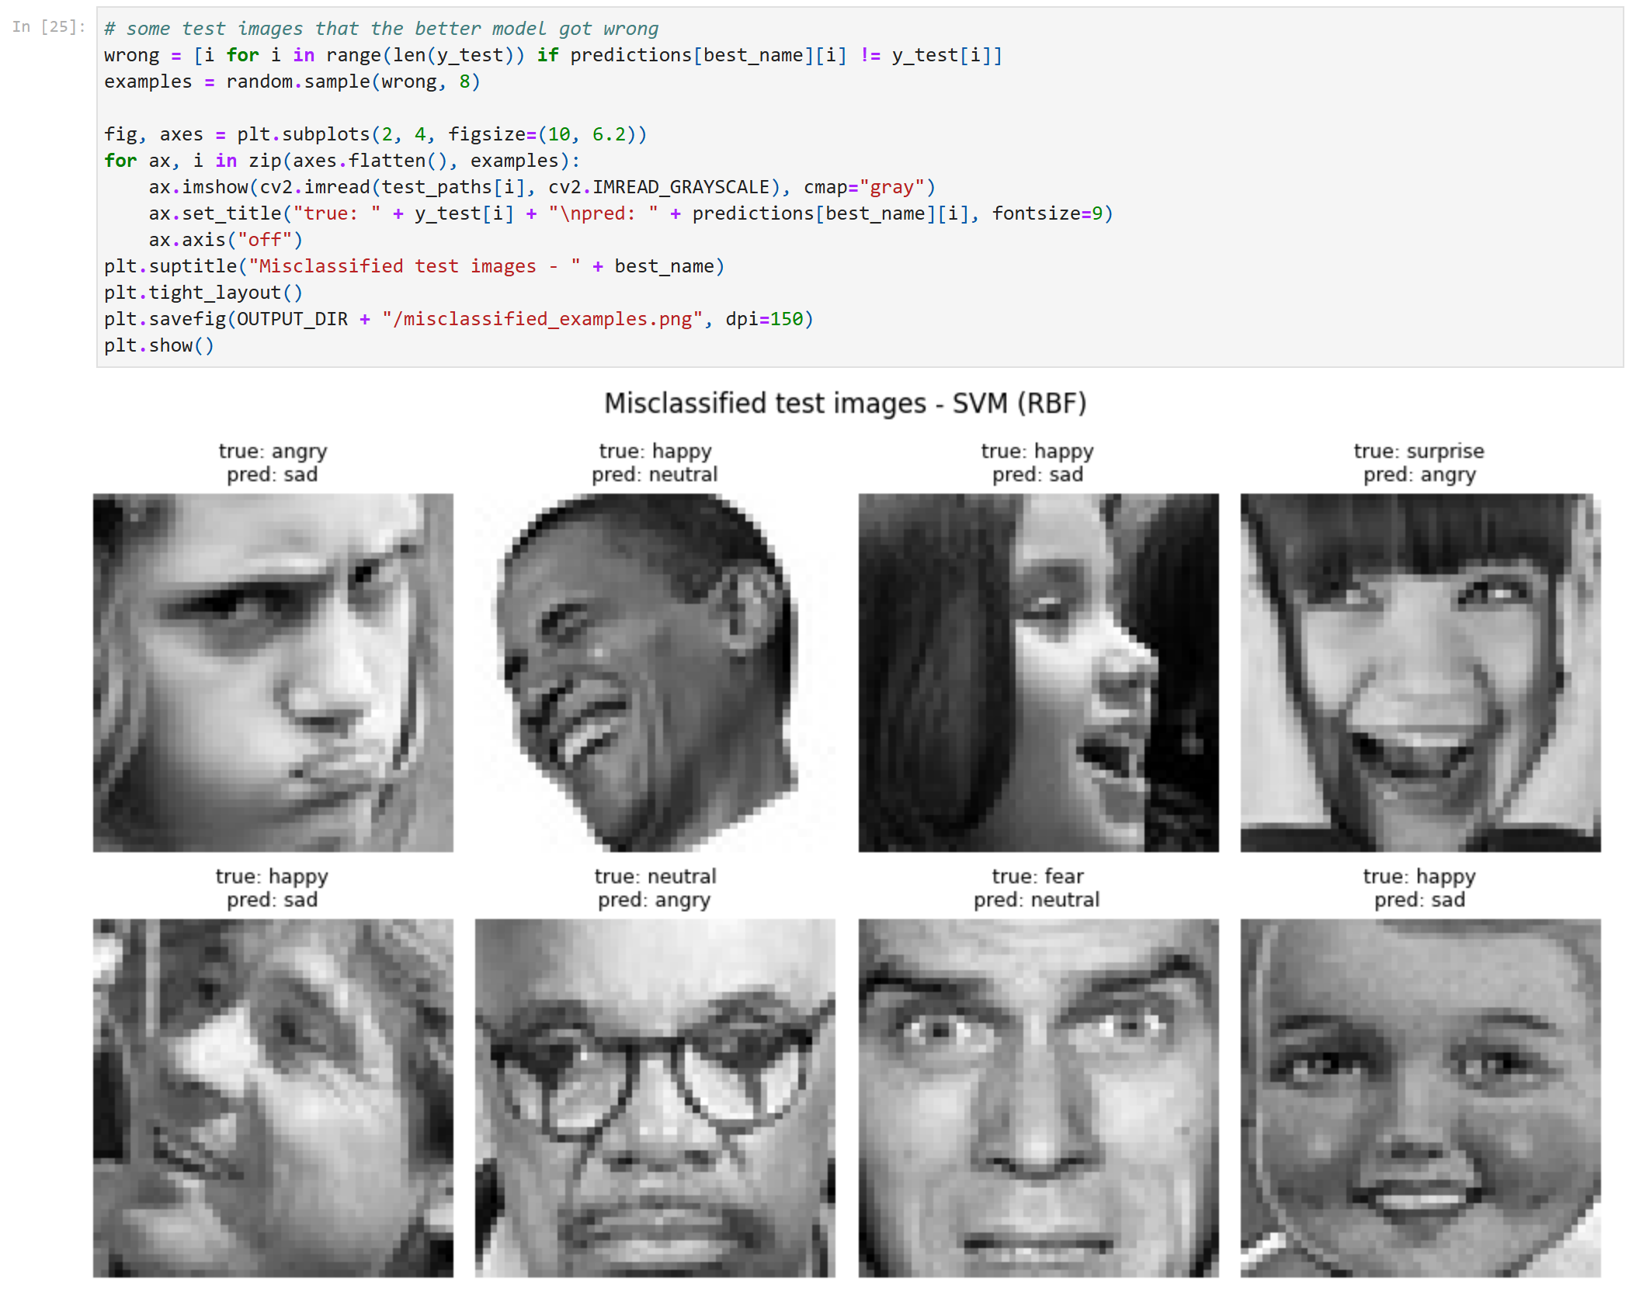
Random test images the SVM got wrong
Looking at the mistakes, many of the faces are turned to the side or tilted, partly covered by a hand, or wearing glasses, and some are very blurry. A few labels also look questionable to me, for example a "happy" face that looks more neutral or sad. FER2013 is known to have noisy labels (human accuracy is only about 65%), so some errors are not really the model's fault. A frozen ImageNet CNN also wasn't trained to notice the small muscle movements (action units) that separate fear from surprise or sad from neutral.
COMPARATIVE SUMMARY
Model | Accuracy | Macro-Precision | Macro-Recall | Macro-F1
Logistic Regression | 0.4804 | 0.4276 | 0.4651 | 0.4356
SVM (RBF) | 0.5268 | 0.5030 | 0.5247 | 0.5100

F1 per class | angry | disgust | fear | happy | sad | surprise | neutral
Logistic Regression | 0.37 | 0.23 | 0.33 | 0.67 | 0.39 | 0.60 | 0.46
SVM (RBF) | 0.43 | 0.47 | 0.37 | 0.68 | 0.44 | 0.69 | 0.49

- Better model: SVM (RBF). It wins on accuracy (+4.6 points) and macro-F1 (+0.074). The RBF kernel can separate emotions that are not linearly separable in the CNN feature space. It got 961 test images right that Logistic Regression missed, and the reverse happened for only 628.
- Hardest classes: fear and sad. With the SVM their F1 scores are 0.37 and 0.44. Fear spreads its errors over sad, surprise, angry and neutral.
- Disgust gained the most from the SVM. Its F1 went from 0.23 to 0.47 even though it has only 436 training images, but it is still often mistaken for angry.
- Easiest classes: surprise and happy (F1 0.69 and 0.68) because of their very distinctive mouth shapes.
- Trade-off: the SVM took about 3.5x longer to train than Logistic Regression (138 s vs 40 s) and has no probability output by default. The overall accuracy is still limited because the CNN was trained on ImageNet objects, not faces.
EXTRA: RANDOM FOREST COMPARISON
The lab asks for two models, and I picked the SVM as my second one. To check that this was a good choice, I also trained a Random Forest (500 trees, min_samples_leaf = 2, class_weight = balanced_subsample, random_state = 42) on the same MobileNetV2 features and the same train/test split.
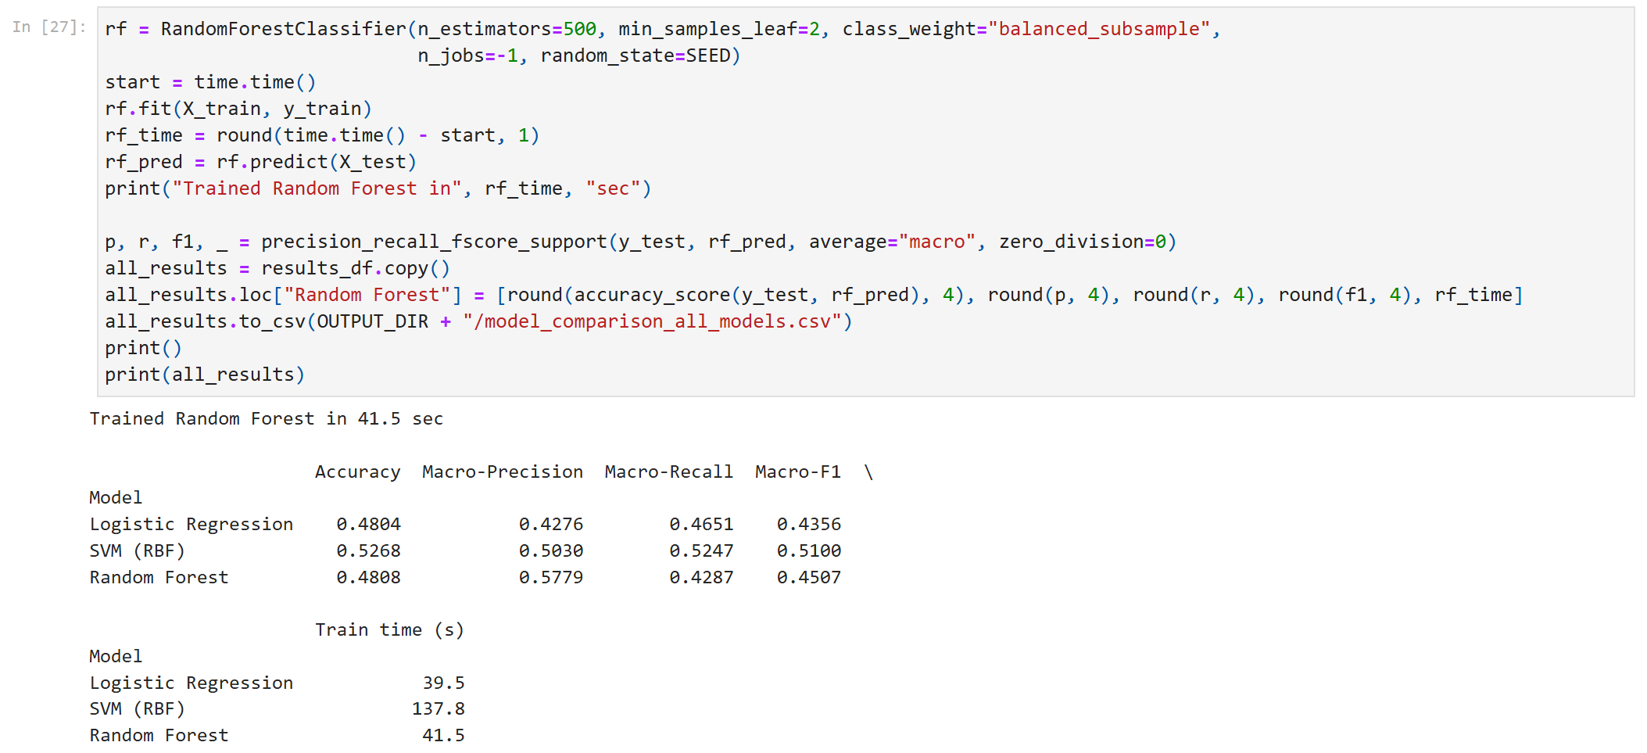
Training the Random Forest and comparing all three models
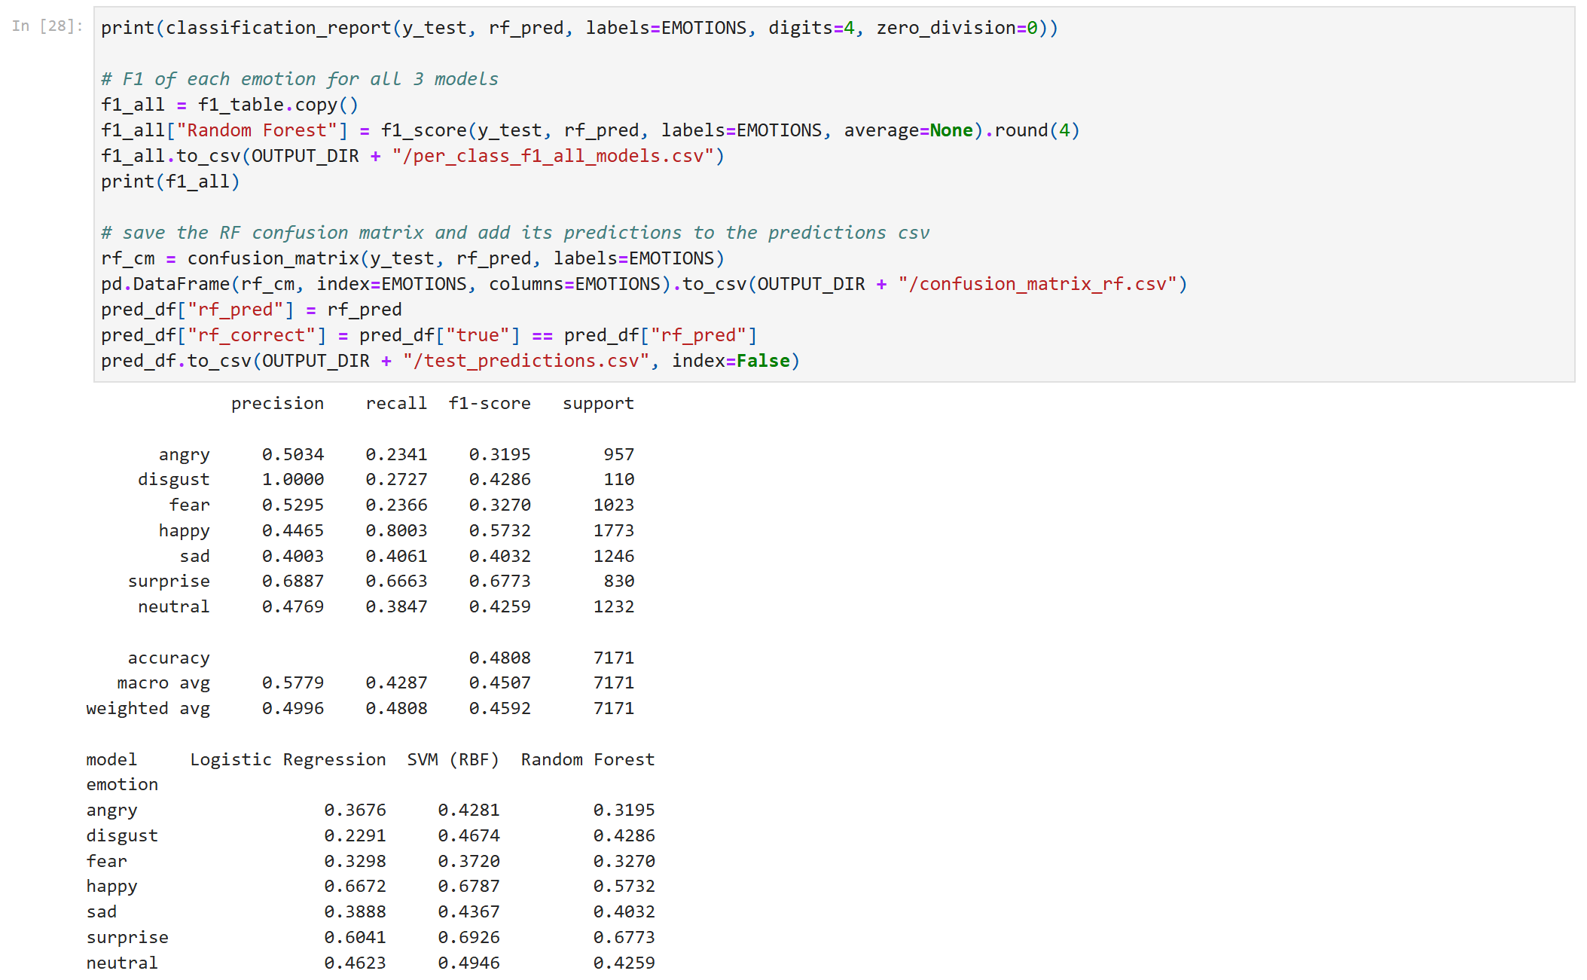
Random Forest classification report and per-class F1 of all three models
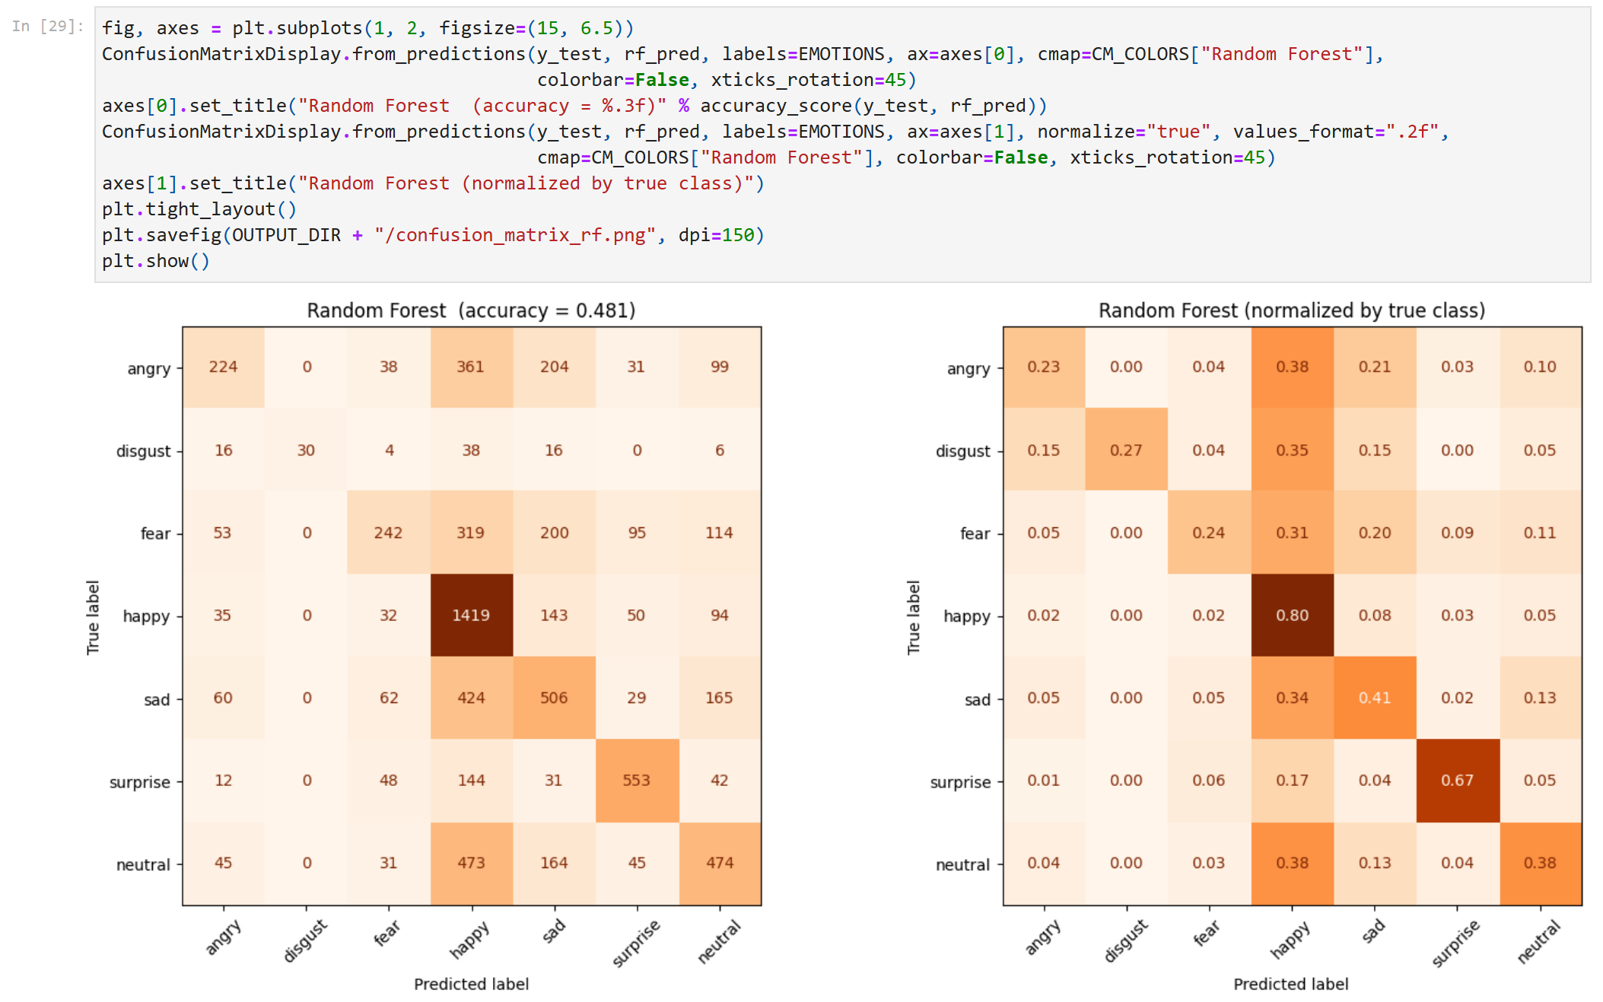
Random Forest confusion matrices (orange)
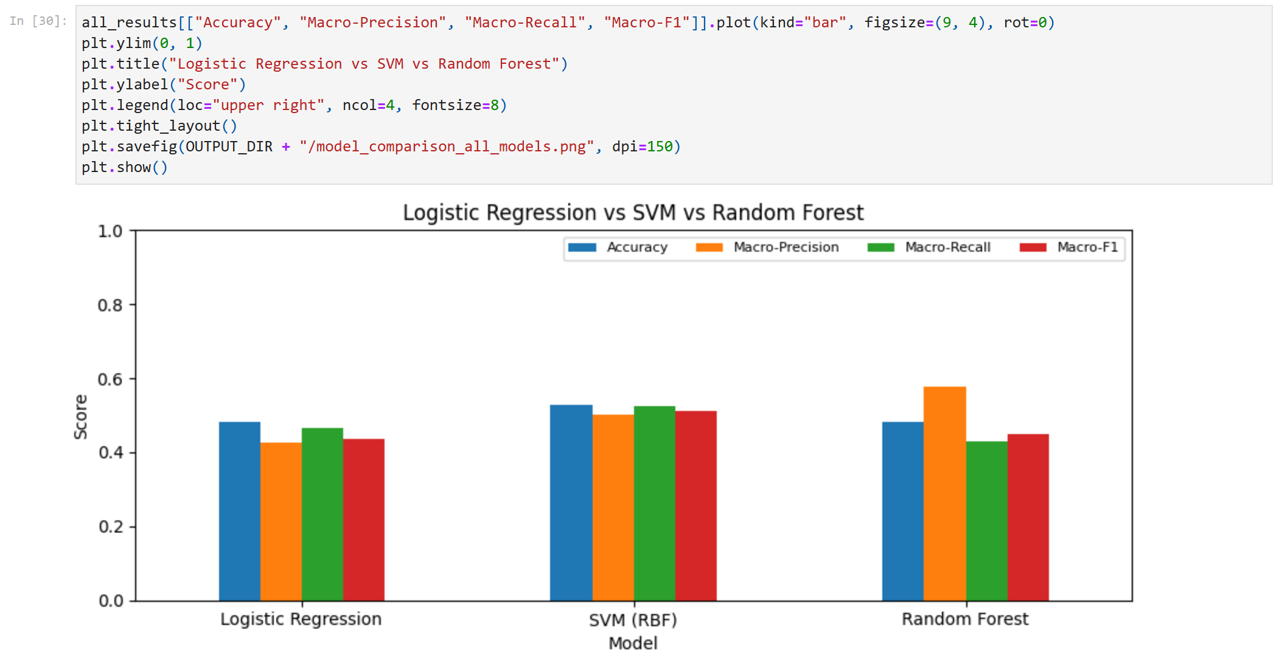
Accuracy, macro-precision, macro-recall and macro-F1 of the three models
Model | Accuracy | Macro-Precision | Macro-Recall | Macro-F1 | Train time
Logistic Regression | 0.4804 | 0.4276 | 0.4651 | 0.4356 | 40 s
SVM (RBF) | 0.5268 | 0.5030 | 0.5247 | 0.5100 | 138 s
Random Forest | 0.4808 | 0.5779 | 0.4287 | 0.4507 | 42 s

DISCUSSION:
Random Forest got 48.1% accuracy and 0.451 macro-F1. That is a little better than Logistic Regression on macro-F1 (0.436) but clearly worse than the SVM (52.7%, 0.510). Random Forest has the highest macro-precision of the three (0.578) but the lowest macro-recall (0.429). From its classification report, it predicts happy, the biggest class, too often (recall 80% but precision only 45%), and it misses most of the angry, fear and disgust faces (recall 23%, 24% and 27%). Its one advantage is speed: it trained in 42 s, compared with 138 s for the SVM. Overall, the test confirms that the SVM is the right second model for these CNN features.
PREDICT FUNCTION PROOF
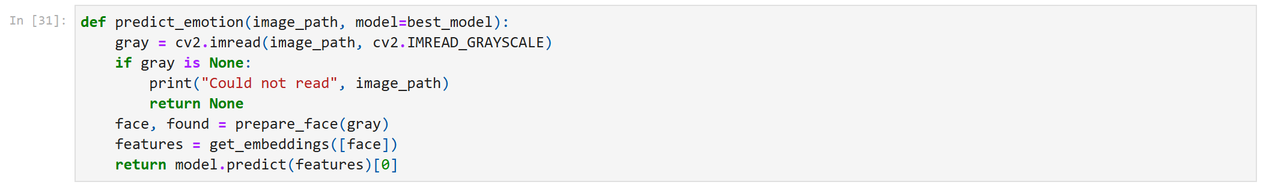
predict_emotion(): same preprocessing + feature extraction, then the SVM
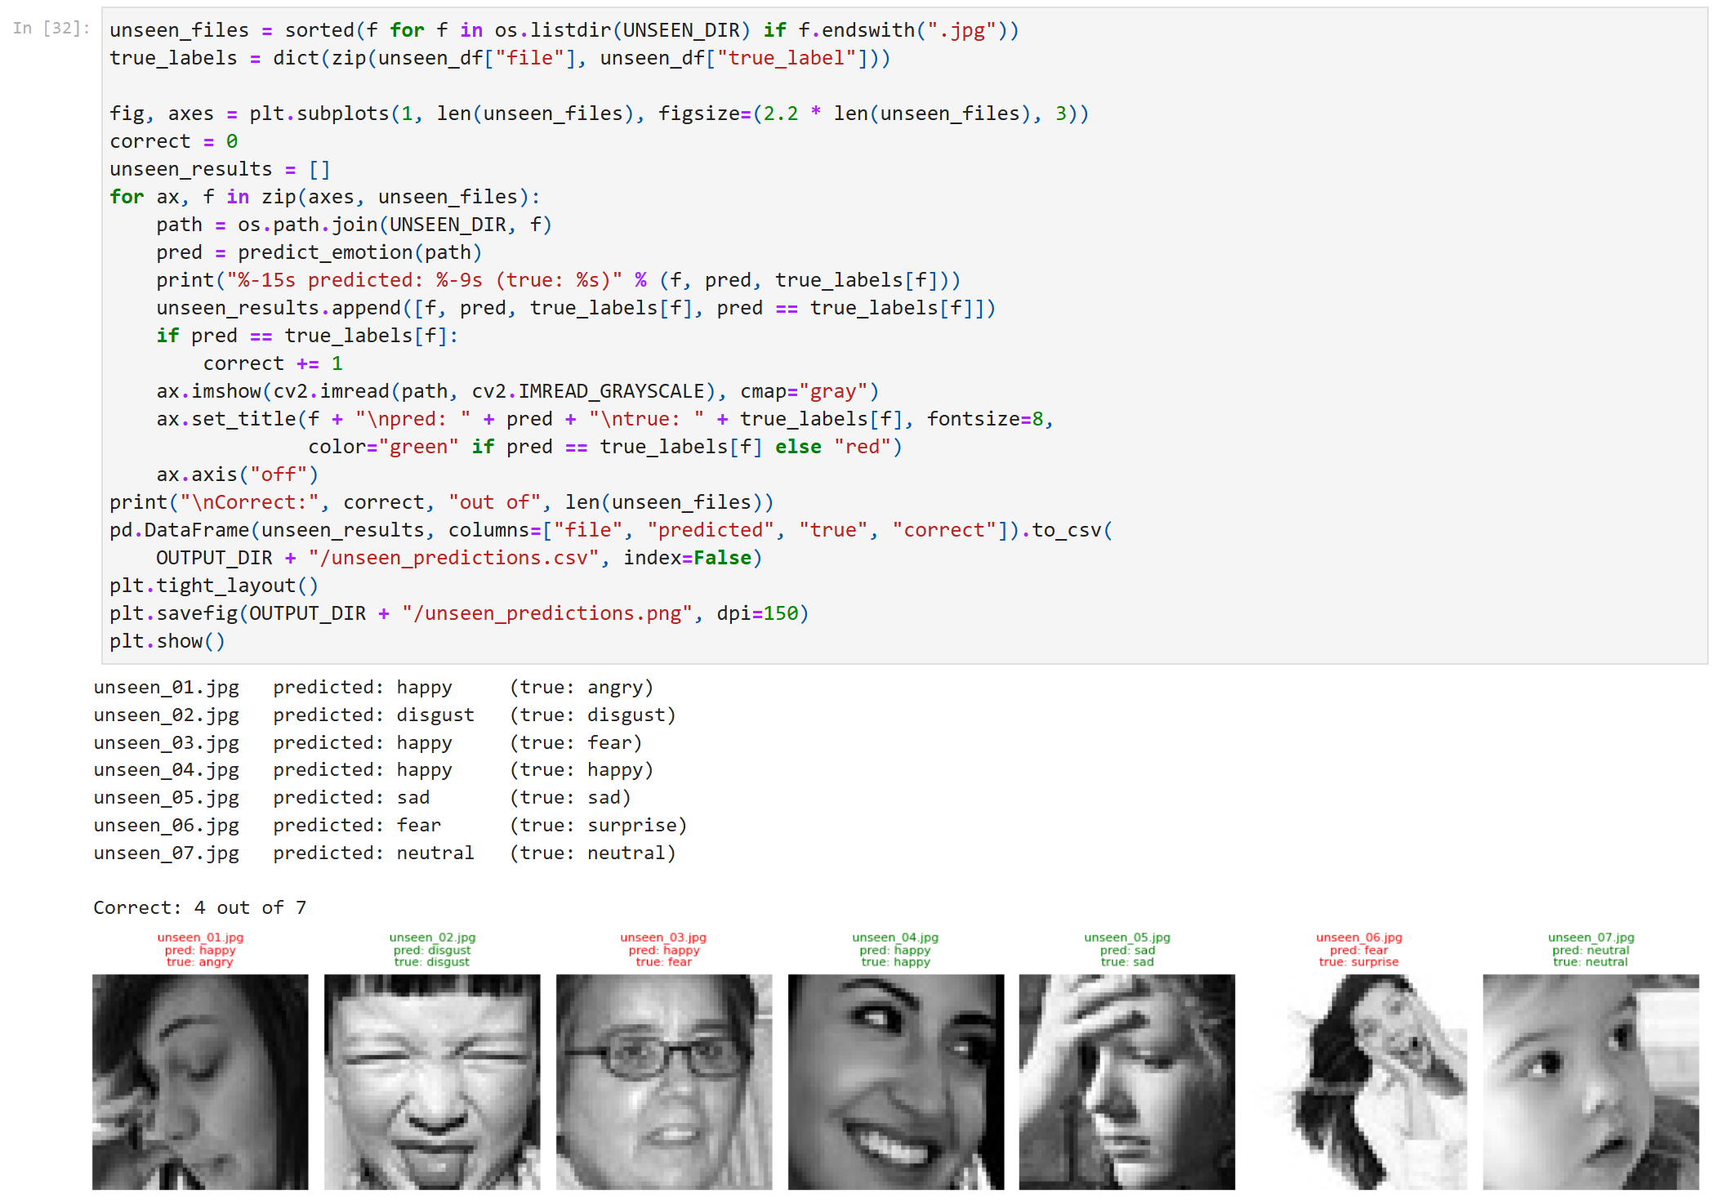
Predictions on the seven unseen images (filenames + predicted labels)
DISCUSSION:
The predict_emotion() function reads an image file, runs the exact same steps as training (Haar face detection and crop, resize to 224x224, 3 channels, MobileNetV2 embedding), and returns one of the seven emotion labels using the SVM, the better of the two models. I tested it on the seven images in unseen_images, which were never used for training or evaluation. It got 4 out of 7 correct. The disgust, happy, sad and neutral images were predicted correctly. The angry face (eyes closed, hand on the face) and the fear face were predicted as happy, and the surprise image, a small tilted face on a white background, was predicted as fear. These mistakes match the confusions seen in the evaluation.
SAVED RESULT FILES (CSV)
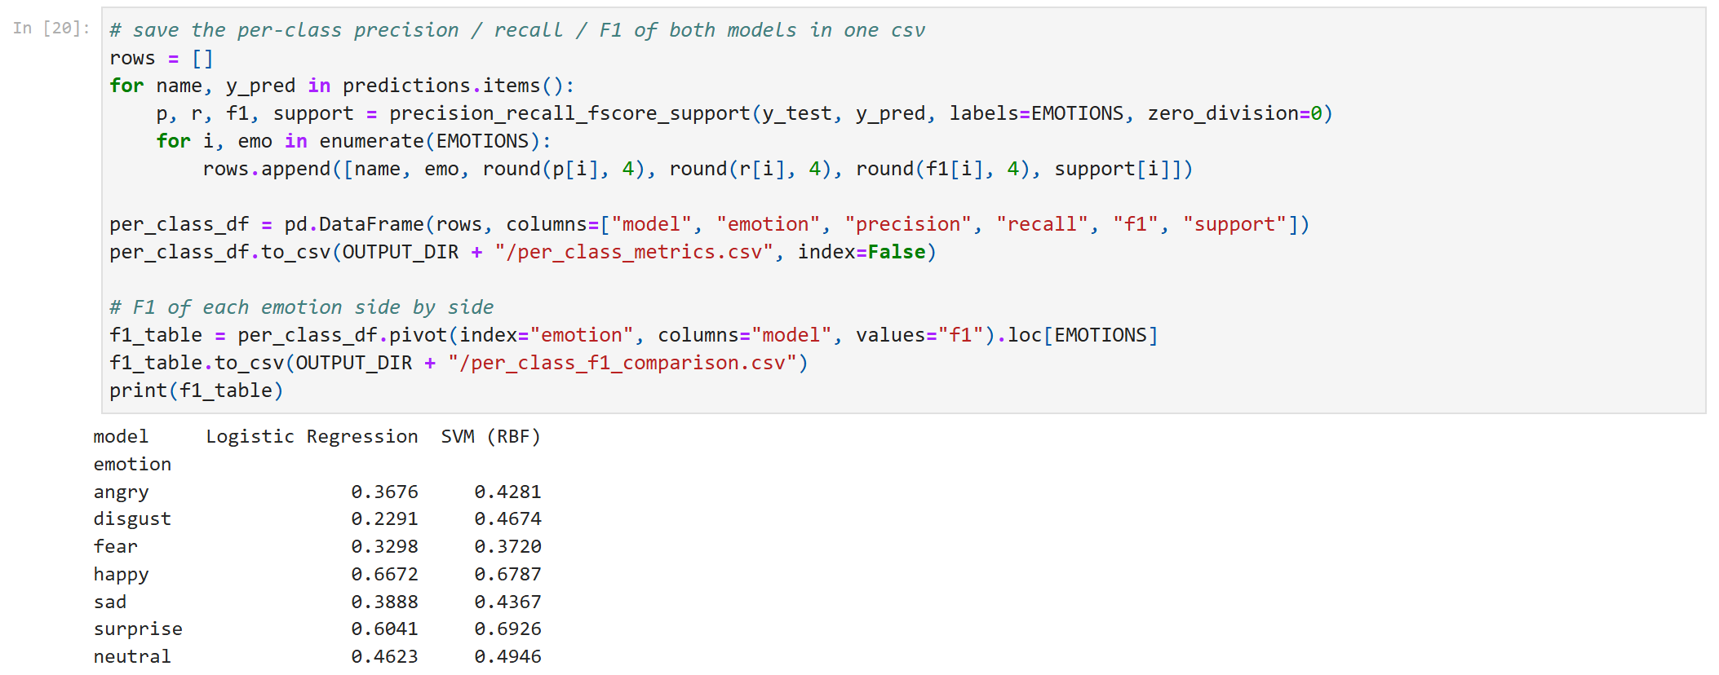
Per-class metrics of both models saved to CSV
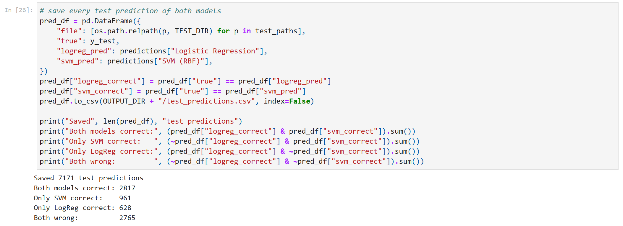
Every test prediction saved to CSV (the Random Forest column is added in the comparison section)
All of the model comparison results are saved in the OUTPUTS folder so they can be opened in Excel:
- model_comparison.csv: accuracy, macro-precision, macro-recall, macro-F1 and training time of both models
- model_comparison_all_models.csv and per_class_f1_all_models.csv: the same results with the Random Forest added
- per_class_metrics.csv and per_class_f1_comparison.csv: precision, recall and F1 of every emotion for both models
- confusion_matrix_logistic.csv, confusion_matrix_svm.csv and confusion_matrix_rf.csv: the 7x7 confusion matrices (counts)
- top_confusions.csv: the five most common confusions of each model
- logreg_validation.csv: the validation results used to choose C
- test_predictions.csv: the true label and the Logistic Regression, SVM and Random Forest predictions for each of the 7,171 test images
- unseen_predictions.csv: the predict-function results on the unseen images
REFLECTION AND IMPROVEMENTS
- Fine-tune the CNN on FER2013 instead of only using frozen ImageNet features. ImageNet features were learned for objects, not facial expressions.
- Use data augmentation (flips, small rotations) and oversample disgust to deal with the class imbalance.
- Use a better face detector (e.g. MediaPipe) and align the faces using the eye positions.
- Combine the CNN features with landmark features from Track A (eye and mouth aspect ratios), which are easier to interpret.
- Tune the SVM's C and gamma with cross-validation. I kept the defaults because each SVM fit takes several minutes on my CPU.

